**Factory Design Pattern Concept (Layman View)**

Imagine you run a toy shop, and you want to make different types of toys like cars, dolls, and airplanes. Each toy type requires different materials and a different process to make. Now, instead of having one big machine that tries to make all types of toys, which can get quite complicated, you decide to have separate "factories" for each type of toy. Each factory specializes in making one type of toy and knows exactly what materials and steps are needed to make that toy.

In software terms, the factory method is a design pattern. A design pattern is like a blueprint for solving common problems in software design. The factory method is used when we have a superclass (a general category) with multiple subclasses (specific categories). Instead of asking the superclass to create an object, we delegate the creation to subclasses.

Back to our toy shop analogy, the "superclass" would be the general concept of a toy, and the "subclasses" would be specific types of toys like cars, dolls, and airplanes. The factory method allows each type of toy to have its own factory that knows how to create that specific toy.

In real-world software, this means that when we need to create an object (like a toy in our analogy), we use a method (the factory) in the subclass to do it. This makes our code more modular (organized into separate parts), easier to manage, and adaptable. If we need to add a new type of toy to our shop, we just add a new factory without messing with the existing ones.

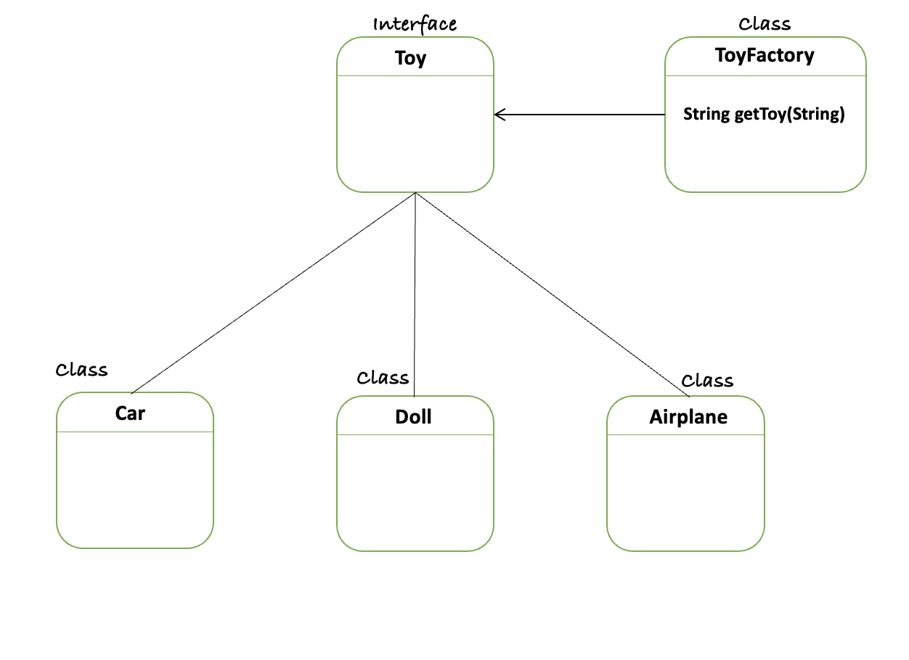

// Toy.java

public interface Toy {

String createToy();

}

// Car.java

public class Car implements Toy {

@Override

public String createToy() {

return "Car toy created with wheels and a body";

}

}

// Doll.java

public class Doll implements Toy {

@Override

public String createToy() {

return "Doll toy created with fabric and yarn";

}

}

// Airplane.java

public class Airplane implements Toy {

@Override

public String createToy() {

return "Airplane toy created with wings and a fuselage";

}

}

// ToyFactory.java

public class ToyFactory {

public Toy getToy(String toyType) {

switch (toyType) {

case "car":

return new Car();

case "doll":

return new Doll();

case "airplane":

return new Airplane();

default:

throw new IllegalArgumentException("Toy type not supported");

}

}

}

// Main.java

public class Main {

public static void main(String[] args) {

ToyFactory factory = new ToyFactory();

Toy car = factory.getToy("car");

System.out.println(car.createToy());

Toy doll = factory.getToy("doll");

System.out.println(doll.createToy());

Toy airplane = factory.getToy("airplane");

System.out.println(airplane.createToy());

}

}

**Factory Design Pattern Examples in Java**

java.sql.DriverManager: This class has a method getConnection that returns different types of Connection objects depending on the connection URL.

Connection conn = DriverManager.getConnection("jdbc:mysql://localhost:3306/mydb", "user", "pass");

**When to Use the Factory Design Pattern:**

* **Complex Creation Logic:** When the creation logic of an object is complex or involves a lot of setup, a factory can encapsulate that complexity.
* **Extensibility:** When your code needs to be extensible to allow adding new types of products without changing existing client code.
* **Decoupling:** When you need to decouple the creation of objects from the system that uses the objects. This helps to follow the Open/Closed Principle (one of the SOLID principles), allowing the system to remain open for extension but closed for modification.
* **Flexibility and Control:** When you want more flexibility in your code by providing different types of object instantiation or configuration settings.
* **Object Pooling:** When instances of classes are expensive to create and can be reused, a Factory can manage a pool of instances.

### When Not to Use the Factory Design Pattern:

* **Simple Object Creation:** If the object creation is straightforward and does not involve any additional logic, using a factory might be an over-engineering.
* **Single Product Line:** If your application only ever needs to create one variant of a product, a factory pattern is unnecessary.
* **Class Hierarchy Overhead:** If implementing a factory pattern creates a large hierarchy of classes or interfaces that are difficult to maintain, it might not be worth the added complexity.
* **Direct Construction Required:** There are times when you need to construct objects directly for clarity and simplicity, especially when dealing with simple domain models.

### Pitfalls of the Factory Design Pattern:

* **Complexity:** Overusing the Factory pattern can lead to unnecessary complexity in the code. If a factory is overkill, it can make the code harder to understand and maintain.
* **Indirection:** The Factory pattern adds an extra layer of indirection to object creation. If not managed well, this can lead to problems in understanding the flow of the application.
* **Refactoring Challenges:** Introducing a Factory pattern into an existing codebase that was not designed for it can be challenging and might require extensive refactoring.
* **Dependency Management:** Factories may introduce additional dependencies that could affect the instantiation if not properly managed, especially in dependency injection scenarios.
* **Testing Overhead:** Testing can become more difficult if the factories are complex, as they may require additional mocking or setup in unit tests.